Determine if the two triangles are similar:

1.  
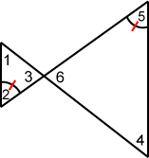

2.  
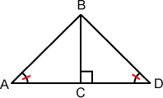

3.  
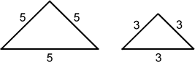

4.  
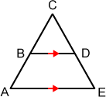

5.  
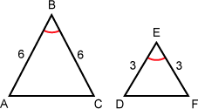

6.  
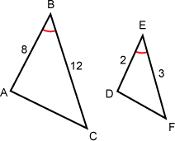

7.  
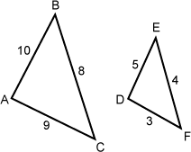

8.  
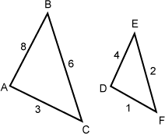

9.  
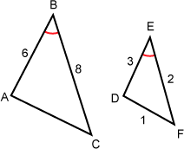

10.  
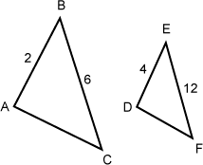

Find x for problems 11 - 14; assume the triangles are similar:

11.  
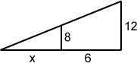

12.  
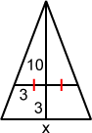

13.  
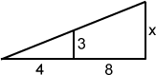

14.  
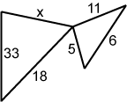

Find the following:

15.A child 4 feet tall stands in line of a shadow cast from the top of the house.   The shadow hits the top of the child's head, and continues until the shadow ends two feet from the child's shoes.   The distance from the tip of the shadow to the house is 14 feet.  
  
Find the height of the house.

16.A person 6 feet tall stands in line of a shadow cast from the top of the house.   The shadow hits the top of the person's head, and continues until the shadow ends three feet from the person's shoes.   The distance from the tip of the shadow to the house is 18 feet.  
  
Find the height of the house.

17.A large tree is in Nancy's front yard and she would like to know its height.   She notices a light ray from the top of the tree to the ground.   The end of the light ray is 50 feet from the base of the tree.   Nancy places a two foot stick so that it's in line with the light ray and the ground.   She measures and finds the spot where the stick intersects the light ray and the ground is 4 feet from the point where the light ray strikes the ground.  
  
Find the height of the tree.

18.A large tree is in Nancy's front yard and she would like to know its height.   She notices a light ray from the top of the tree to the ground.   The end of the light ray is 55 feet from the base of the tree.   Nancy places a three foot stick so that it's in line with the light ray and the ground.   She measures and finds the spot where the stick intersects the light ray and the ground is 6 feet from the point where the light ray strikes the ground.  
  
Find the height of the tree.

19.Mary wants to find the height of a tree.   She places a mirror on the ground 8 feet from the tree.   She then stands where she can see the top of the tree in the mirror.   Mary is 1 foot from the mirror and her eyes are 5 feet above the ground.   A light ray forms the same angle with the mirror as its reflection.  
  
Find the height of the tree.

20.Mary wants to find the height of a tree.   She places a mirror on the ground 9 feet from the tree.   She then stands where she can see the top of the tree in the mirror.   Mary is 2 foot from the mirror and her eyes are 6 feet above the ground.   A light ray forms the same angle with the mirror as its reflection.  
  
Find the height of the tree.

Find x, assume the triangles are similar.:

21.  
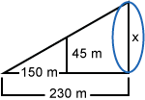

22.  
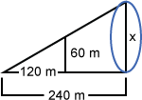

Prove the following:

23.Prove theorem 2.1.2 using similar triangles:  
If the mid-segment is drawn in a triangle, then it is parallel to the side that is not included in the mid-segment.

24.Prove theorem 2.1.3 using similar triangles:  
If the mid-segment is drawn in a triangle, then it is half the length of the side not included in the mid-segment.

25.Given:    ||   
  
Prove:   https://my.westcottcourses.com/images/common/triangle.gifAEB https://my.westcottcourses.com/images/common/similar14.gif https://my.westcottcourses.com/images/common/triangle.gifDEC  
  
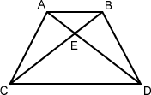

26.Given:    ||   
  
Prove:   https://my.westcottcourses.com/images/common/triangle.gifABE https://my.westcottcourses.com/images/common/similar16.gif https://my.westcottcourses.com/images/common/triangle.gifCDE  
  
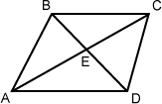

27.Given:   BA  
 = DE  
  
  
Prove:    ||   
  
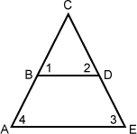

28.Given:    ||   
  
Prove:   BA  
 = DE  
  
  
